Chemistry Unit 4 Review
Substances
You will want to be able to match up characteristics to the following types of substances:
Element
Compound
Mixture
Pure Substance
You should also be able to look at particle diagrams and categorize them as one of the above and as either a solid, liquid or a gas. Try the following ones: 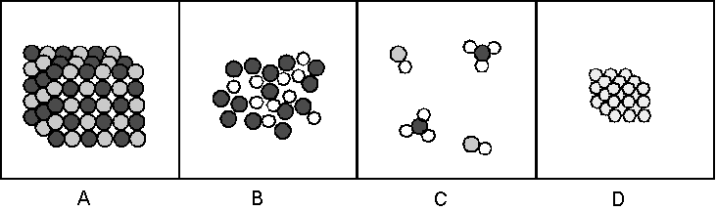
A_________ B________________ C_______________ D____________________
What would the heating curve of a mixture of two substances be? How would it compare to a compound made up of the two substances? Try drawing both heating curves.

How can we separate mixtures? How can we separate compounds? Elements?

You should be able to draw particle diagrams of mixtures and compounds. Remember that equal volumes of gases have equal numbers of particles (not necessarily of atoms) at the same temperature and pressure

Finally, we should be able to do mass ratio calculations.
A 1.0 g sample of hydrogen reacts completely with 19.0 g of fluorine to form a compound of hydrogen and fluorine.
- What is the percent by mass of each element in the compound?
- What mass of hydrogen would be present in a 50 g sample of this compound?
- Justify your answer to b.
- Draw a particle diagram of the reaction

