Geometry Study Guide: Triangle Congruence Proofs, Dilations and Similarity

Triangle Congruence Proofs:
What is the Geometric definition of congruence?

When we do proofs, we start with our givens. We then label any parts of our figure that we need, extend any lines or create parallel lines, perpendicular lines, bisections, or whatever (in the proof, under statements place a statement of fact about the line you constructed, and under justifications you state “construction”. So if you constructed line DC parallel to AB, you would state AB parallel to DC, and under justifications you would write “construction”)
Do following proof:
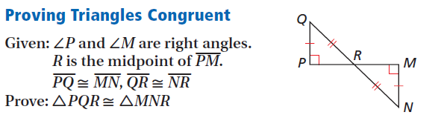

What are the Triangle congruence criteria? List them and draw example congruent triangles for each criteria

Once we have proven that triangles are congruent, we can extend that proof with CPCTC. What does CPCTC mean?

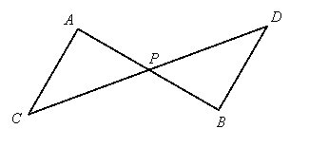
Given: and is the midpoint of
Prove: is the midpoint of

More complicated proofs will require us to do the exact same steps but in stages: use one triangle congruence to show a second pair are congruent, and then use that pair to prove the next set, and so on until you have proven your goal.

Scale and Dilations
Scale the following figure from the Center of dilation O with a scale factor of r=3. LIST YOUR STEPS

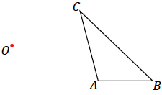

If a figure has been dilated, there exists a scale factor that will allow us to find the lengths of the resulting figure. If AB is the length of a side of the original figure, and A’B’ is the length of the image, rAB=A’B’. This is also true of BC and B’C’; rBC=B’C’.
Use algebra to solve for r for both equations. then tell me what that means about AB, BC, A’B’ and B’C’:

Similarity
What is the geometric definition of similarity?

What are the three similarity criteria? List them and explain what they mean

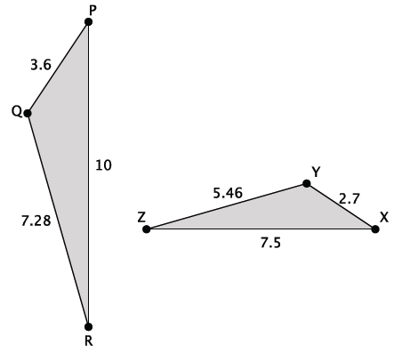
Are the triangles below similar? If so, state the criterion you used:

What is the midsegment theorem?

What is the triangle angle bisector theorem?

Find the lengths of x and y
